W03 Project: Rafting Site – Planning Document

1. Site Logo 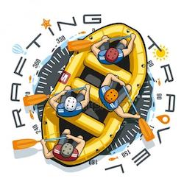
2. Color codes:
   * primary-color – light sky blue 98D1FF change to Engineering orange #D00000
   * secondary-color – lemon lime EAF815 change to Selective yellow #FFBA08
   * accent1-color – Erin 25FE33 change to Steel blue #3F88C5
   * accent2-color – orange F5801E change to Prussian blue #032B43
3. Font Labels
   * heading-font – Lora
     + <link rel="preconnect" href="https://fonts.googleapis.com">
     + <link rel="preconnect" href="https://fonts.gstatic.com" crossorigin>
     + <link href="https://fonts.googleapis.com/css2?family=Lora:ital,wght@0,400..700;1,400..700&family=Roboto:ital,wght@0,100..900;1,100..900&display=swap" rel="stylesheet">
     + .lora-<uniquifier> {
     + font-family: "Lora", serif;
     + font-optical-sizing: auto;
     + font-weight: <weight>;
     + font-style: normal;
     + }
   * text-font – Roboto
     + <link rel="preconnect" href="https://fonts.googleapis.com">
     + <link rel="preconnect" href="https://fonts.gstatic.com" crossorigin>
     + <link href="https://fonts.googleapis.com/css2?family=Lora:ital,wght@0,400..700;1,400..700&family=Roboto:ital@0;1&display=swap" rel="stylesheet">
     + .roboto-<uniquifier> {
     + font-family: "Roboto", sans-serif;
     + font-optical-sizing: auto;
     + font-weight: <weight>;
     + font-style: normal;
     + font-variation-settings:
     + "wdth" 100;
     + }
4. URL Link to color palette
   * https://coolors.co/eaf815-98d1ff-14fe33-f5801e